**Injury and illness surveillance at FIFA tournaments 2023-2028**

Dear player,

We would like to invite you to participate in this research project performed by the Fédération Internationale de Football Association (FIFA).

Your participation is voluntary. All data collected will be handled following strict data protection procedures.

The most important points of the research project are described below, and more detailed information is presented on the following pages. If you have any questions relating to your participation in the project, please feel free to get in touch with your team physician or the project’s principal investigator, whose contact details can be found below.

Why are we conducting this research project?

* Injuries & illnesses can effect a player’s performance, career, and future health.
* International competitions are reported to have the highest risk of injury.
* In this research project, our aim is to collect information on injuries and illnesses during FIFA tournaments.
* This information is important to document how big a problem injuries and illnesses are, so we can improve the prevention of injuries and illnesses in football in the future.

What do you have to do to participate?

* You simply need to provide your consent to allow the anonymous analyses of data recorded by your own medical staff.
* Your participation does not require any further action on your part. Your data will be encrypted (which means it has a code instead of your name) before it is analysed for this research project, and data will be published anonymously.
* If you provide an additional consent, we will also connect your injury data with match video footage to analyse how the injury occurred. This will allow identification of you and the video footage may be shown to others (for scientific and educational purposes only). We will not share the video footage (nor any image from this) with your injury details without your approval in this consent form.
* If you do not wish to participate, that will not affect any rights or benefits that you normally have.

Benefits

* By participating in this research project, you help provide an overview of injuries and illnesses at the highest level of football, which will guide our efforts to protect the health of football players, not only in future World Cups but other settings as well.

Risk and burdens

* There are no perceived risks involved in participation. All data will be coded to ensure that you are not identifiable in this research project.

With your signature, you confirm that you understand the entire document and you are participating in this project voluntarily.

Detailed project information

1. Aim and selection

The primary goal of this research is to provide an overview of injuries and illnesses and their characteristics during FIFA tournaments. It is possible for you to participate because you have been selected to represent your country in a FIFA tournament.

1. General information

* Injuries in football are connected with team performance. Teams are more likely to lose matches where players have sustained injuries, and teams with fewer injuries have better results both in international tournaments and in national leagues.
* The amount of illnesses during international football tournaments are unclear.
* Senior level international tournaments have been shown to have a higher injury rate than lower levels of football.
* There is a need for improved research to better understand the amount, the seriousness, and the causes of injuries and illnesses in football.
* We would like to know how many injuries and illnesses occur during FIFA tournaments, and how serious these are.
* By participating, you allow us to use your information on any possible injuries and illness during the tournament and how much you train and play matches.
* All data will be encrypted using a unique participant number prior to analysis. Published data will be anonymous.
* The research project will include injuries and illnesses occurring during the tournament only. If you get an injury or illness during the tournament, we would also like to know when you return to football.
* If you provide an additional consent, we will also connect your injury data with match video footage to analyse how injuries occur. This will allow identification of you and the video footage may be shown to others for scientific and educational purposes. We will not share the video footage (nor any image from this) together with your injury details without your additional approval.
* We are doing this research project following the laws in Switzerland. A Swiss medical research ethics committee have approved the research project.

1. Procedure

The study will start from the first day of training with the national team under the auspices of FIFA prior the tournament. Injuries and illness occurring until the day of the last match of the tournament will be included. In order to assess the severity of injuries (based on the length of time a player is unable to play for), all injuries are recorded until they are fully rehabilitated, even if this is after the end of the tournament.

Data on injury and illness is collected following the most recent recommendations on methods (The football extension of the International Olympic Committee consensus statement on methods for recording and reporting of epidemiological data on injury and illness in sport). This includes characteristics such as mode of onset (whether the symptoms came sudden or gradually), injury mechanism (how the injury occurred), diagnosis, and classification according to body area, tissue, and pathology type, and illness categories for organ system and aetiology. Time-loss (the period you will not be able to play football) will be counted in number of days.

Your training and match exposure will be recorded in minutes on a weekly basis for the duration of the tournament. Training exposure includes any sports-specific training, strength and conditioning sessions, and active recovery sessions. Illness exposure will be recorded in days from your arrival in the host country until your last match.

This information will be registered by your team medical contact, which means you will not be required to carry out any additional procedures as a result of your participation.

1. Benefits

You will not gain any immediate direct benefit from participating in this research project, but through your participation, you will help football players globally.

1. Voluntariness and obligations

Participation is voluntary.

If you do not wish to participate in this research project, or you later wish to withdraw your participation, you do not have to justify this. This will not affect any rights or benefits that you normally have.

You have no obligations as a participant in this research project.

1. Risks and burdens

There are no perceived risks involved in participation. All data will be encrypted (coded) and only your team medical contact person and the research team will have access to the coding.

1. Alternatives

If you prefer not to participate in this research project but are open to participating in other research projects on this subject, you are welcome to contact us.

1. Results

In principle, you have the right to be informed about findings that could have a direct impact on your health. However, in this type of research projects, the results will usually have no significance for the individual patient, or will not allow any conclusion to be drawn about your individual health or treatment. Therefore, we will not inform you specifically. Please consider whether you are comfortable with this before participating in the study. We will send your team a summary of the overall results at the end of the research project. You are also welcomed to contact the project leader for further information on the overall results at any given time.

The overall results of this research will be disseminated anonymously internally within FIFA and shared with other key stakeholders (including, in the case of the Olympic Football Tournament, the International Olympic Committee as tournament co-organisers). The results will also be submitted for publication in an international sports medicine journal and may be further disseminated externally through various media outlets, press conferences, scientific conferences, etc.

1. Confidentiality of data
   1. Data processing and encryption

For this research project, data collected will be encrypted before analysis. This means that data that could directly or indirectly identify you (name, date of birth, etc.) will not be disclosed. The following data will be gathered: your age, height, weight, information on any potential injuries and/or illnesses you may get during the tournament, and how much you train and play matches during the tournament. If you provide an additional consent, we will also connect your injury data with match video footage to analyse how injuries occur. This will allow identification of you and the video footage may be shown to others for scientific and educational purposes. We will not share the video footage (nor any image from this) together with your injury details without your specific approval for this in this consent form.

* 1. Data protection and storage

FIFA always complies with any obligations and safeguards individuals’ rights under Swiss and European Union laws. FIFA puts suitable measures in place in order to safeguard and secure data under its control. If you have any questions about how FIFA processes data, please visit <https://www.fifa.com/data-protection-portal>. The data will be stored indefinitely (min. 10 years).

* 1. Disclosure in the event of inspections

This research project may be reviewed by the responsible ethics committee and by the project managers. The investigator will be obliged to disclose your data for such checks; in such cases, everyone involved will be required to maintain the strictest confidentiality.

1. Withdrawal

You can withdraw from the research project at any time. In the event of withdrawal, the already collected data may still be analysed, but must remain anonymous after the analysis.

1. Costs and compensation

Participation in this research project will not lead to any costs for you or your health insurance provider. You will not receive any compensation for your participation.

1. Funding

The research project is funded by the Fédération Internationale de Football Association.

1. Contact person

You may ask questions about project participation at any time.  
If you have any queries during or after the project, please contact:

Dr Benjamin Clarsen

Medical Researcher – Global Injury and Illness Surveillance

FIFA Medical

+41 79 523 34 71

ben.clarsen@fifa.org

Fédération Internationale de Football Association

FIFA-Strasse 20, P.O. Box 8044 Zurich, Switzerland

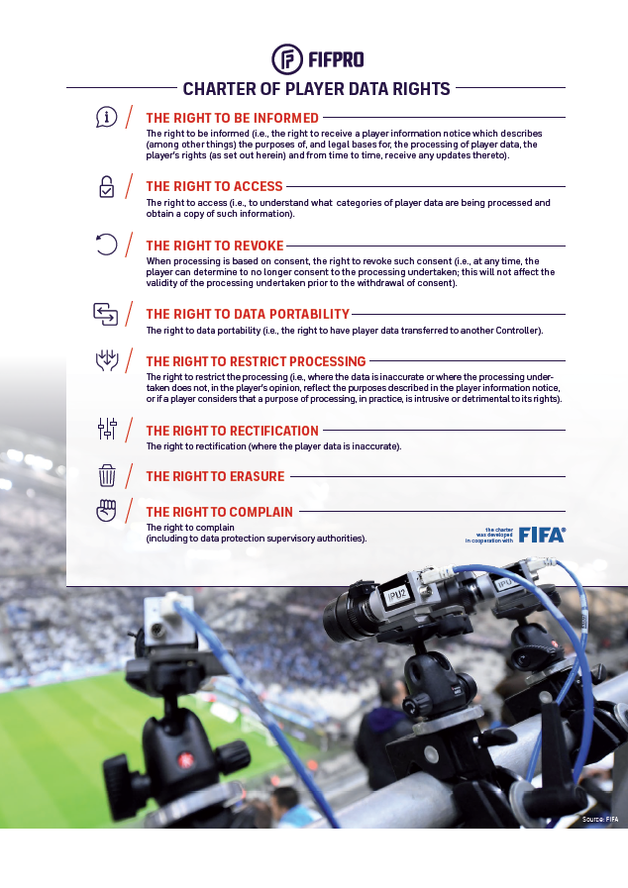

Consent

**Declaration of consent for participation in this research project**

Please read this form carefully and ask if there is anything that you do not understand or wish to know. Your written consent is required to participate.

|  |  |
| --- | --- |
| Ethics committee numbers: | BASEC: 2023-00772 |
| Title of the research project: | Injury and illness surveillance at FIFA tournaments 2023-2028 |
| Institution running the research project: | Fédération Internationale de Football Association |
| Place of implementation: | International |
| Head of the research project: | Ben Clarsen |

* I have been informed about the purpose and nature of this research project, as well as the possible advantages, disadvantages, and risks.
* I am voluntarily participating in this research project and acknowledge and accept the information provided in the above research project description. I have had enough time to make my decision.
* My questions regarding participation in this research project have been answered. I have been given a copy of the information about the project and provide my consent.
* In the event of results that directly affect my health, I will be notified. If I do not wish to be notified, I will inform my team doctor accordingly.
* I know that my health and personal data can only be shared in encrypted form for this research project. FIFA guarantees that data will be protected in compliance with Swiss standards.
* I can withdraw my participation at any time and without the need to explain this decision. My further treatment does not depend on my participation in this research project. Any data collected up to that point may still be used and analysed for the purposes of this research project.

**Participant**

☐ I consent to the use of my information according to the above research project description.

☐ I consent to further use of my information in future research projects approved by a medical research ethics committee.

☐ I consent to the use of information about my (potential) injury for video analysis of injury mechanisms. I understand that this will allow identification of me and that the video footage may be shown to others for scientific and educational purposes.

|  |  |
| --- | --- |
|  |  |
| First name and surname in block capitals | Date of birth |
|  |  |
| Place, date | Signature of the participant |

**Declaration by the investigator/team physician**

I hereby confirm that I have explained the nature, significance and scope of this research project to this participant. I will fulfil all obligations in connection with this research project in accordance with the applicable Swiss laws. If, in the course of the research project, I learn of any information that could influence the willingness of the participant to be involved in the research project, I will inform them immediately.

|  |  |
| --- | --- |
|  | |
| First name and surname of the investigator in block capitals | |
|  |  |
| Place, date | Signature of the investigator |